**Practical (CC): 12-09-2023**

**Aim:**

**Step 1:** Install Julia 1.9.2

**Step 2:** Type the following Code:

import Pkg; Pkg.add("Plots")

using Plots

x=1:15

y=100:115

f(x,y)=begin

x^2+y^2

end

contour(x,y,f,fill=true,plot_title="contour plot")

savefig("output/plot.png)

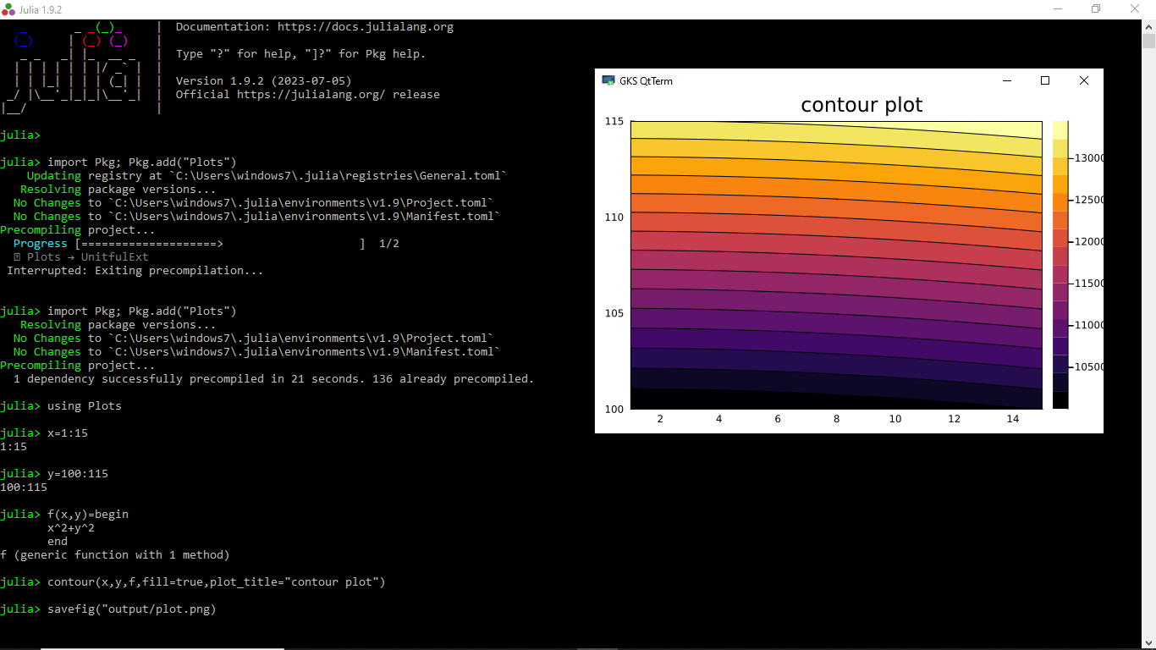

**Output:**

